Binary Alpha Shader – Joshua Kauer

In my own engine

Made it so any fragment that has a color of white will be discarded. The cube with the texture being affected by this should be right in front of you. I currently have back face culling on, to help assist with seeing through the texture. It has a leaf texture with a white background. Actually writing and implementing the shader didn’t take too long, but I did spend quite a bit figuring out what shaders do and how they work. I also spent some time trying to figure out how to implement shaders in my own engine, and I did this by adding lighting back into my engine.

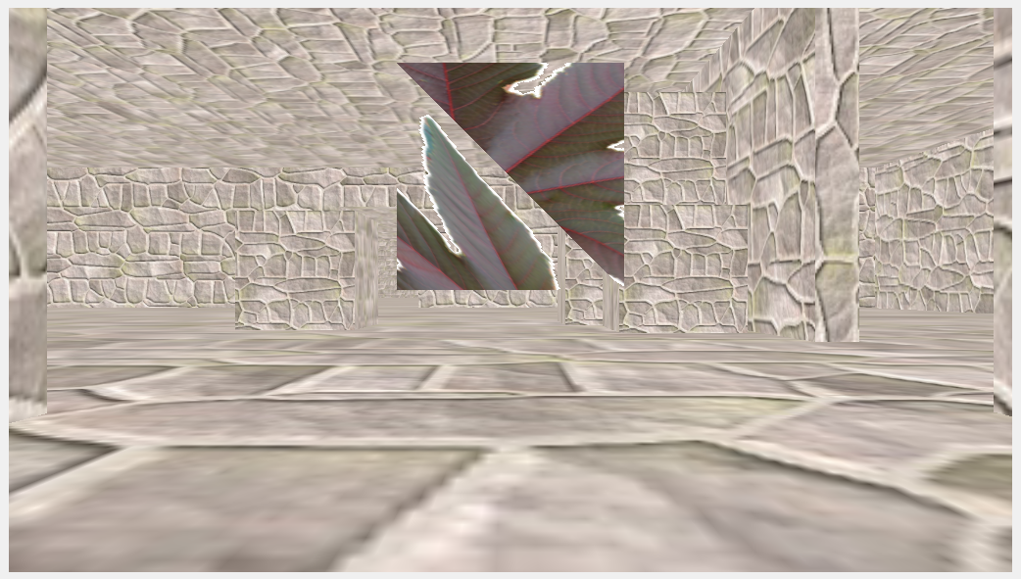

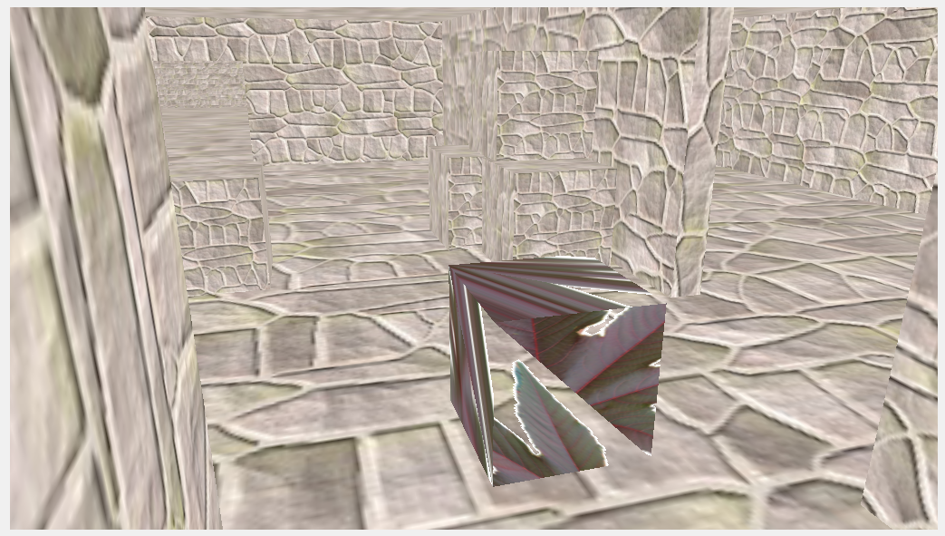

**Vertex Shader:**

#version 430

in layout(location = 0) vec4 position;

in layout(location = 1) vec2 vertexUV;

out vec2 UV;

uniform mat4 modelToProjectionMatrix;

void main(){

gl_Position = modelToProjectionMatrix * position;

UV = vertexUV;

}

**Fragment Shader:**

#version 430

in vec2 UV;

out vec3 color;

uniform sampler2D myTexture;

void main()

{

vec3 tmp = texture(myTexture, UV).rgb;

if(tmp == vec3(1.0, 1.0, 1.0))

discard;

color = tmp;

}

https://svn.neumont.edu:8443/!/#sp16_cg_jkauer/view/head/Lab01%20-%20BinaryAlpha

revision 6